
NASHIK CAMBRIDGE SCHOOL

(Academic Year 2024-25)

Project Report

on

Submitted by:

Sr. | Name of Student | Class/Div.
No.
1)
2)
3)
4)
5)

Place: Nashik Cambridge School, Nashik

NASHIK CAMBRIDGE SCHOOL
DEPARTMENT OF COMPUTER SCIENCE

(Academic Year 2024-25)

CERTIFICATE
This is to certify that, the project report entitled
“ ”

has been successfully completed by:
1. | class: | Roll No:
2. | class: | Roll No:
3. | class: | Roll No:
4. | class: | Roll No:
5. | class: | Roll No:

as a partial fulfillment of Class Xth from Nashik Cambridge School (Department of Computer Science), affiliated to Central Board of Secondary Education CBSE, Delhi during the academic year 2024-25.
The said work has been assessed by us and we are satisfied that the same is up to the standard envisaged for the level of the course.

Date: / /2024

Mr./ Ms. Prof. Shunmugasundar
Subject Teacher Principal

ACKNOWLEDGEMENT

In the accomplishment of this project successfully, many people have bestowed upon me their blessings and the heart pledged support, this time I am utilizing to thank all the people who have been concerned with this project.

Primarily I would thank God for being able to complete this project with success. Then I would like to thank our principal Mr. Shunmugasundar and computer teacher Mr./Mrs.
, whose valuable guidance has been the ones that helped me patch this project and make it full proof success. His/her suggestions and his instructions have served as the major contributor towards the completion of the project.

Then I would like to thank my parents and friends who have helped me with their valuable suggestions and their guidance has been very helpful in various phases of the completion of the project.

Last but not the least I would like to thank my classmates who have helped me a lot.

Table of Contents

Sr.No. | Name of Topic | Page no.
1 | Abstract
2 | Introduction
3 | Theory (Usage of tags used in project)
4 | HTML Code
5 | Output Screens
6 | Conclusion
7 | References

Abstract

Our project provides a comprehensive look into website creation by linking multiple pages using HTML and CSS. It demonstrates how each HTML tag functions, contributing to the desired webpage layout.

This website showcases a coaching class, including details about courses, their frequency, and fee structures. Not only does it incorporate hyperlinks for seamless navigation between pages, but it also leverages CSS for enhanced design.

Throughout the project, various tags and attributes were used, each serving a unique purpose in text formatting and organizing information. We utilized table tags to clearly display course-related data, such as schedules and fees, making it easy for users to comprehend.

Additionally, our project includes tags beyond our syllabus to further enrich the web design. CSS styles were integrated to ensure that navigation elements, such as the navbar, are user-friendly.

To conclude, this project showcases our understanding of HTML and CSS fundamentals, achieved through external references and applied to a real-world website project, fully documented in our bibliography.

Introduction

In this project you will get to know about various codes used in making of our website of coaching class and you will have an outlook of our website. Our website contains information about the coaching class and what it offers along with the fee structure of respective courses.

We have used many appropriate tags to design the multiple web pages to design our desired website. We have used all the tags that we have been taught in this academic year of 2024-25. But we have used many other tags apart from our syllabus. Along with tags we have appropriate attributes to design our website. We have used table tag and its attributes for displaying the courses we offer, fee structure, frequency, etc.

We have used horizontal rule tags for enclosing important lines or titles within it a paragraph tags for making tags. We have used text formatting tags and its attributes to make the text more attractive and to highlight the main points to read. We have also used the definition list for defining some terms that are necessary to understand along with it, we have used the nested list to include some sub-points within the numbered topics.

Image tag along with its attributes is used to display our logo in left top corner for recognition. Link tag and its attributes have also been used to link to external style sheets. Pre tag is used to display the text in preformatted text as typed in the coding platform.

We have even used some CSS properties for our website like we used navbar, as it helps in easy navigation which is important for any website. We have even centered the content using CSS. Content containers are also used to pad the content inside them.

It is just an overview of what you are going to see forward and what are the codes that run in the in the background of our website.

Theory

HTML tags used:
- <a>:- The <a> tag defines a hyperlink, which is used to link from one page to another. The most important attribute of the <a> element is the href attribute, which indicates the link's destination.

- <b>:- The <b> tag specifies bold text without any extra importance.

- <p>:- The <p> tag defines a paragraph. Browsers automatically add a single blank line before and after each
<p> element.

- <u>:- The <u> tag represents some text that is unarticulated and styled differently from normal text, such as misspelled words or proper names in Chinese text. The content inside is typically displayed with an underline. You can change this with CSS.

- <tt>:- The <tt> tag was used in HTML 4 to define teletype text.

- <ul>:- The <ul> tag defines an unordered (bulleted) list. Use the <ul> tag together with the <li> tag to create unordered lists.
Attributes: - 1) compact-Sets or returns whether the unordered list should render smaller than normal, or not.
2) Type-Sets or returns the value of the type attributes of an unordered list.
- <ol>:- The <ol> tag defines an ordered list. An ordered list can be numerical or alphabetical. The <li> tag is used to define each list item.
Attributes-1) Type-Sets or returns the value of the type attribute of an ordered list.
  - Start-Sets or returns the value of the start attributes of an ordered list.

- <tr>:- The <tr> tag defines a row in an HTML table.A <tr> element contains one or more <th> or <td> elements.

- <td>:- The <td> tag defines a standard data cell in an HTML table. Attributes- 1) colspan-Specifies the number of columns a cell should span.
  - rowspan-Sets the number of rows a cell should span.
  - headers- Specifies one or more header cells a cell is related to.

- <hr>:- The <hr> tag defines a thematic break in an HTML page (e.g. a shift of topic).The <hr> element is most often displayed as a horizontal rule that is used to separate content (or define a change) in an HTML page.

Attributes-
- align- Sets or returns the alignment of a horizontal line.
- color- Sets or returns the color of a horizontal line.
- noshade- Sets or returns whether a horizontal line should render in one solid color (noshaded).
- size- Sets or returns the height of a horizontal line.
- Width- Sets or returns the width of a horizontal line B- formatting tag.

- <br>:- The <br> tag inserts a single line break. The <br> tag is useful for writing addresses or poems. The <br> tag is an empty tag which means that it has no end tag.

- <h1> to< h6>:- The <h1> to <h6> tags are used to define HTML headings. <h1> defines the most important heading. <h6> defines the least important heading.

  - Attributes- align- Sets or returns the value of the align attribute of the heading element.

- <sub>:- The <sub> tag defines subscript text. Subscript text appears half a character below the normal line, and is sometimes rendered in a smaller font. Subscript text can be used for chemical formulas, like H2O.

- <sup>:- The <sup> tag defines superscript text. Superscript text appears half a character above the normal line, and is sometimes rendered in a smaller font. Superscript text can be used for footnotes, like ¹H.

- <img>:- The <img> tag is used to embed an image in an HTML page. Images are not technically inserted into a web page; images are linked to web pages. The <img> tag creates a holding space for the referenced image. The <img> tag has two required attributes:-
- src - Specifies the path to the image
- alt - Specifies an alternate text for the image, if the image for some reason cannot be displayed
- crossorigin-Allow images from third-party sites that allow cross-origin access to be used with canvas
- height- Specifies the height of an image
- width-Specifies the width of an image

- <pre>:- The <pre> tag defines preformatted text. Text in a <pre> element is displayed in a fixed-width font, and the text preserves both spaces and line breaks. The text will be displayed exactly as written in the HTML source code.

- <link>:- The <link> tag defines the relationship between the current document and an external resource. The
<link> tag is most often used to link to external style sheets or to add a favicon to your website. The <link> element is an empty element, it contains attributes only.
Attributes- 1) href-Specifies the location of the linked document.
2) rel-Required. Explains how the current document relates to the referenced one.

- <html>...</html>:- The <html> tag represents the root of an HTML document. Attributes- 1-) Dir- Specifies the text direction for content.
2) lang- Specifies the language of elemental content.

- <title>:- The <title> tag defines the title of the document. The title must be text-only, and it is shown in the browser's title bar or in the page's tab. The <title> tag is required in HTML documents.

- <font>:- The <font> tag was used to specify the font face, font size, and color of text.

- <body>:- The <body> tag defines the document's body. The <body> element contains all the contents of an HTML document, such as headings, paragraphs, images, hyperlinks, tables, lists, etc.
Attributes- a) alink- Sets or returns the color of an active link in a document.
- background- Sets or returns the background image for a document.
- bgcolor - Sets or returns the background color of a document.
- link- Sets or returns the color of unvisited links in a document.
- text - Sets or returns the color of the text in a document.
- vlink- Sets or returns the color of visited links in a document

- <head>:- The <head> element is a container for metadata (data about data) and is placed between the <html> tag and the <body> tag. Metadata is data about the HTML document. Metadata is not displayed. Metadata typically define the document title, character set, styles, scripts, and other Meta information.

- <center>:- The tag is used in HTML4 to center align text/content.

Tags other than syllabus:
- <footer>:- The <footer> tag defines a footer for a document or section.

- <meta>-The <meta> tag defines metadata about an HTML document. Metadata is data (information) about data. meta tags always go inside the <head> element, and are typically used to specify character set, page description, keywords, author of the document, and viewport settings.
Metadata will not be displayed on the page, but is machine parable. Metadata is used by browsers (how to display content or reload page), search engines (keywords), and other web services. There is a method to let web designers take control over the viewport (the user's visible area of a web page), through the <meta> tag.

- <div>:- The <div> tag defines a division or a section in an HTML document. The <div> tag is used as a container for HTML elements - which is then styled with CSS or manipulated with JavaScript.

Some other css properties used:
- .navbar:- Having easy-to-use navigation is important for any web site. With CSS you can transform boring HTML menus into good-looking navigation bars.
- .navbar li::after:- The .navbar li::after pseudo element can be used with navigation bars to create horizontal tricks.
- .navbar li:hover::after:- The .navbar li::after pseudo element can be used with navigation bars to create hover tricks.
- center-content: - The most common and (therefore) easiest type of centering is that of lines of text in a paragraph or in a heading. CSS has the property 'text-align'.
- .content-container:- The content Containers are used to pad the content inside of them, and there are two containers.
- .hero-btn: - A Hero Image is a large image with text, often placed at the top of a webpage.

Html and Css code

style.css:
* {
margin: 0;
padding: 0;
}

body {
background: linear-gradient(rgba(28, 39, 85, 0.7), rgba(28, 39, 85, 0.7)), url('Ref/banner.jpg'); color: white;
font-family: 'Times New Roman', serif;
}

.navbar {
list-style: none; padding: 35px; margin: 0; display: flex;
justify-content: flex-end; position: relative;
}

.navbar li {
margin-left: 20px; position: relative;
}

.navbar li a {
text-decoration: none; color: white;
}

.navbar li::after { content: ""; width: 0; height: 2px;
background: #01d0e7; display: block; margin: auto; transition: width 0.5s; position: absolute; bottom: -5px;
left: 0;
}
.navbar li:hover::after { width: 100%;
}

.navbar li a { color: red;
}

img {
position: absolute; top: 5;
left: 5;
margin-left: 50px; margin-top: 30px;
}

.center-content { display: flex;
flex-direction: column; justify-content: center; align-items: center; height: calc(100vh - 100px); margin-top: 100px;
}

h1 {

}

text-align: center;
font-family: 'Times New Roman', Times, serif; color: white;
margin-top: 220px;

.hero-btn {
display: inline-block;
text-decoration: none; Page 6

color: #fff;
border: 1px solid #fff; padding: 12px 34px; font-size: 13px; background: transparent; position: relative; cursor: pointer;
}
.hero-btn:hover{
border: 1px solid #01d0e7; background: #01d0e7; transition: 0.95s;
}

.center-content { display: block; margin-top: 50px; text-align: center;
height: calc(100vh - 200px);
}

home.html:
<html>
<head>
<title>Coaching Classes</title>
<link rel="stylesheet" href="style.css">
<meta rel="icon" href="Ref/favicon.png" type="image/png">
<style>
p {
text-align: center; color: white;
font-family: 'Times New Roman', Times, serif;
}
</style>
</head>
<body>
<font face="Yatra One">
<ul class="navbar nav-links">
<li><a href="home.html">HOME</a></li>
<li><a href="about.html">ABOUT</a></li>
<li><a href="courses.html">COURSES</a></li>
<li><a href="blog.html">BLOG</a></li>
<li><a href="contact.html">CONTACT</a></li>
</ul>
</font>
<a href="home.html"><img src="Ref/logo.png" height="150" width="150"></a>
<h1>One of India's Leading Classes </h1>
<br>
<p>Learn with Us: Dive into a World of Fun and Knowledge! Experience the joy of learning in an
engaging and vibrant environment. <br>
Our unique approach ensures that education is not just informative but also enjoyable. <br> Join us and immerse yourself in a community where curiosity meets creativity, <br>
and every day is an adventure in the pursuit of knowledge</p>

<div class="center-content">
<a href="courses.html" class="hero-btn">Visite us to know more</a>
</div>
</body>
</html>

about.html:
<html>
<head>
<title>Coaching Classes</title>
<link rel="stylesheet" href="style.css">
<style>
hr{border: none;
border-top: 3.5px solid white;
}
p{margin-left: 40px; font-size: 20;
}
h1{text-align: center; color: white;
margin-top: -10;
}
img {
position: absolute; top: 5;
left: 5;
margin-left: 25px; margin-top: 6px;
Page 7

}
</style>
</head>
<body>
<font face="Yatra One">
<ul class="navbar nav-links">
<li><a href="home.html">HOME</a></li>
<li><a href="about.html">ABOUT</a></li>
<li><a href="courses.html">COURSES</a></li>
<li><a href="blog.html">BLOG</a></li>
<li><a href="contact.html">CONTACT US</a></li>
</ul>
<a href="home.html"><img src="Ref/logo.png" height="100" width="100"></a> <br>
</font>
<hr>
<br>
<h1> ~~~ About Us ~~~</h1> <br>
<hr> <br><br>
<p>Coaching Classes was established on 12 April 2010 with enormous vision to provide the best education in a different, innovative and pleasant learning environment in the challenging field of Pre-Engineering entrance exams.</p> <br>

<p>Coaching Classes is committed to help the students in career vision. We inculcate the values of learning. Coaching Classes' target is to make a difference in the way students think and approach problems. It provides excellent study inputs to the students with elective study strategy and dedicated teaching staff in preparing students for these highly competitive examinations.</p> <br>

<p>The devotion and expertise of our teachers and the methodologies followed by us have generated a great confidence among the students and parents, due to which Coaching Classes is regarded as a premier institute for JEE (Main+Advanced), NEET-UG, Olympiads, BITSAT, MHT-CET & other
Pre-Engineering competitive exams preparation at Nashik.</p> <br>

<br>
<p>With PRACTICE, PERSISTENCE & PERFORMANCE under the meticulous mentorship of our teachers, Coaching Classes has been delivering outstanding and quality results each year from Nashik.</p>

<p><b>An experience that is one of its kind and has become mightier with each passing year.</b></p>
</body>
</html>

courses.html:
<html>
<head>
<title>Coaching Classes</title>
<link rel="stylesheet" href="style.css">
<meta rel="icon" href="Ref/favicon.png" type="image/png">
<style>
hr{border: none;
border-top: 3.5px solid white;
}
h2{margin-left: 30;
}
p{margin-left: 40px;
}
table {
border: 1px solid white; border-collapse: collapse; width: 80%;
margin: 0 auto;
}
td, th {
border: 1px solid white; padding: 10px;
font-size: 16px;
}
h1{text-align: center; color: white;
margin-top: -10;
}
img {
position: absolute; top: 5;
left: 5;
margin-left: 25px; margin-top: 6px;
}
</style>
</head>
<body>
<font face="Yatra One">
Page 8
<ul class="navbar nav-links">

<li><a href="home.html">HOME</a></li>
<li><a href="about.html">ABOUT</a></li>
<li><a href="courses.html">COURSES</a></li>
<li><a href="blog.html">BLOG</a></li>
<li><a href="contact.html">CONTACT US</a></li>
</ul>
<a href="home.html"><img src="Ref/logo.png" height="100" width="100"></a> <br>
</font>
<hr> <br>
<h1>*** List of All the Courses We Offer *** </h1> <br>
<hr> <br><br>
<h2>1. IIT-JEE TWO YEAR'S PROGRAM</h2>
<br>
<p>Course Concept: The Aspire course is the best of educational programs, carefully designed to build strong
and knowledgeable students. Over a carefully planned two-year journey, it forms the foundation for students'
studies in Mathematics, Chemistry, and Physics. This program is focused on clear teaching, helping students
understand basic concepts with precision and care. Each lesson is skillfully created to make difficult subjects
easier to understand, helping students deeply learn. Every part, from the basics to the most complex details, is
studied with a strong focus on excellence.</p>
<br>
<p>The Aspire course is more than just a set of lessons—it's a life-changing experience. It helps students go beyond
regular learning, using their knowledge in real-life situations and during tough exams. Each day, students are
not just studying; they are improving their skills and getting ready for future challenges. A key focus of the
Aspire course is on doing well in competitive exams, especially the important JEE Advanced.
With a carefully
planned course and tough practice sessions, students learn the skills and strategies to solve even the hardest
problems. Every idea, formula, and technique is carefully studied and mastered so that no problem is too difficult.</p>
<br>
<p>Beyond academic skills, the Aspire course teaches students discipline and clear, organized thinking. It develops
logical problem-solving skills, teaching students to handle challenges clearly, precisely, and
confidently.
With these important skills, students become not just learners but also creators of their own
success, ready
to face any challenge.</p>
<br>
<p>The Aspire course is more than just a journey—it's a transformation. It shows how education can shape minds,
inspire passions, and unlock the full potential of every student who strives for greatness.</p>
<br><br>
<table>
<tr>
<th>Course Name</th>
<td>IGNITE</td>
</tr>
<tr>
<th>Target Year</th>
<td>2027</td>
</tr>
<th>Who Should Join</th>
<td>For Students Going To Class 11 in 2025</td>
</tr>
<tr>
<th>Course Duration</th>
<td>2 Years</td>
</tr>
<tr>
<th>Frequency of classes</th>
<td>5 days in a week</td>
</tr>
<tr>
<th>Fee Details (for academic session 2025-26)</th>
<td>Course Fee
₹1,80,000<br>
Processing Fee
₹20,000<br>
Total Fee
₹2,00,000 (Incl. GST)<br></td>
</tr>
<tr>
<th>Commencement of Regular Classes</th>
<td>Phase 1 - 21st April 2025 | Phase 2 - 19th May 2025</td>
</tr>
<tr>

<th>Fees Installment</th>
<td>I Installment
Page 9

₹50,000<br>
  - Installment
₹50,000<br>
  - Installment
₹50,000<br>
  - Installment
₹50,000<br> </td>
</tr>
<tr>
<th>Regular Assessment Tests</th>
<td>Bi-weekly</td>
</tr>
</table>
<br><br><br><br><br><br><br>

<h2>2. JEE-MAIN TWO YEAR'S PROGRAM</h2>
<br>
<p>Course Concept: The Ignite JEE-Main Course is a carefully designed two-year program that prepares students for
the Joint Entrance Examination (JEE) Main exam with precision and depth. It covers Mathematics, Chemistry, and
Physics, building a strong foundation for mastering these subjects. The course guides students
from basic
principles to advanced problem-solving techniques for a thorough understanding and strong
performance.</p>
<br>
<p>From the start, the Ignite course provides a transformative learning experience. Students engage in a structured
and dynamic educational journey, focusing on practical application, critical thinking, and strategic problem-solving.
This approach helps students excel in both regular assessments and high-pressure exams.</p>
<br>
<p>A key part of the course is its continuous assessment and personalized feedback. Regular tests and assignments
help students track their progress and find areas for improvement. Experienced instructors provide detailed
feedback to refine knowledge and enhance problem-solving skills, preparing students for the JEE Main exam.</p>
<br>
<p>The Ignite JEE-Main course also emphasizes essential skills such as time management and disciplined study habits.
It offers a structured study plan and practical tips for effective learning, helping students

develop a content and
<br>

disciplined approach to their studies. This holistic approach ensures students master academic build the resilience needed for challenging problems in exams.</p>

<p>Overall, the Ignite JEE-Main Course aims to unlock each student's full potential, preparing them to excel in

skill
the JEE Main examination and beyond. By combining rigorous academic instruction with practical

development and personalized support, the course helps students achieve their highest

aspirations.</p>
<br><br>
<table>
<tr>
<th> Course Name</th>
<td> IGNITE</td>
</tr>
<tr>
<th> Target Year</th>
<td> 2027</td>
</tr>
<th> Who Should Join</th>
<td> For Students Going To Class 11 in 2025</td>
</tr>
<tr>
<th>Course Duration</th>
<td>2 Years</td>
</tr>
<tr>
<th>Frequency of classes</th>
<td>5 days in a week</td>
</tr>
<tr>
<th>Fee Details (for academic session 2025-26)</th>
<td>Course Fee
₹1,80,000<br>
Processing Fee
₹20,000<br>
Total Fee
₹2,00,000 (Incl. GST)<br></td>
</tr>
<tr>

<th>Commencement of Regular Classes</th>
<td>Phase 1 - 21st April 2025 | Phase 2 - 19th May 2025</td>

Page 10

</tr>
<tr>
<th>Fees Installment</th>
<td>I Installment
₹50,000<br>
- Installment
₹50,000<br>
- Installment
₹50,000<br>
- Installment
₹50,000<br> </td>
</tr>
<tr>
<th>Regular Assessment Tests</th>
<td>Bi-weekly</td>
</tr>
</table>
<br><br><br><br><br><br><br>

<h2>3. NEET-UG TWO YEAR'S PROGRAM</h2>
<br>
<p>Course Concept: The Inspire course is a journey designed to help students deeply understand and apply what
they learn right from the start. It helps them easily use their knowledge in real-life situations and exams.
Over two years, this course guides students smoothly and helps build a strong foundation in Biology, Chemistry,
and Physics.</p>
<br>
<p>The course is carefully planned to make each subject clear and easy to understand. It covers everything from basic
ideas to complex details, helping students truly understand instead of just memorizing. The Inspire course isn't
just about theory; it also focuses on practical skills and solving real-world problems.</p>
<br>
<p>Students participate in interactive sessions, experiments, and practice exams, learning both theory and how to
apply it in different situations, getting ready for future challenges. The Inspire course is committed to helping
students excel in competitive exams, especially NEET-UG. With expert guidance and strong support, students are
fully prepared, gaining the skills and strategies to handle even the toughest problems confidently.</p>
<br>
<p>The course is based on teaching that emphasizes clear understanding and organized thinking. It teaches students
to solve problems logically, helping them break down and analyze complex issues, which is a valuable skill in
both academics and life. In short, the Inspire course is more than just learning; it's an experience that helps
shape minds, develop talents, and push students toward academic success.</p>
<br>
<p>It shows how education can spark interests, unlock potential, and lead to a brighter future.</p>
<br><br>
<table>
<tr>
<th> Course Name</th>
<td> Inspire</td>
</tr>
<tr>
<th> Target Year</th>
<td> 2027</td>
</tr>
<th> Who Should Join</th>
<td> For Students Going To Class 11 in 2025</td>
</tr>
<tr>
<th>Course Duration</th>
<td>2 Years</td>
</tr>
<tr>
<th>Frequency of classes</th>
<td>5/6 days in a week</td>
</tr>
<tr>
<th>Fee Details (for academic session 2025-26)</th>
<td>Course Fee
₹2,40,000<br>
Processing Fee
₹20,000<br>
Total Fee
₹2,60,000 (Incl. GST)<br></td>
</tr>
<tr>

<th>Commencement of Regular Classes</th>
<td>Phase 1 - 14th April 2025 | Phase 2 - 12th May 2025</td>

Page 11

</tr>
<tr>
<th>Fees Installment</th>
<td>I Installment
₹65,000<br>
- Installment
₹65,000<br>
- Installment
₹65,000<br>
- Installment
₹65,000<br> </td>
</tr>
<tr>
<th>Regular Assessment Tests</th>
<td>Bi-weekly</td>
</tr>
</table>
<br><br><br><br><br><br><br>
</body>
</html>

blog.html:
<html>
<head>
<title>Coaching Classes</title>
<link rel="stylesheet" href="style.css">
<style>
hr{ border: none;
border-top: 3.5px solid white;
}
h2{margin-left: 30;}

p { margin-left: 40px; margin-right: 40px;
}
.content-container {max-width: 80%; margin: auto; } h1{text-align: center;
color: white; margin-top: -10;
}
img {
position: absolute; top: 5;
left: 5;
margin-left: 25px; margin-top: 6px;
}
</style>
</head>
<body>
<font face="Yatra One">
<ul class="navbar nav-links">
<li><a href="home.html">HOME</a></li>
<li><a href="about.html">ABOUT</a></li>
<li><a href="courses.html">COURSES</a></li>
<li><a href="blog.html">BLOG</a></li>
<li><a href="contact.html">CONTACT US</a></li>
</ul>
<a href="home.html"><img src="Ref/logo.png" height="100" width="100"></a> <br>
</font>
<hr> <br>
<h1>--- Blog ---</h1> <br>
<hr> <br><br>
<h2><u>Unlock Your Potential with Coaching Classes</u></h2> <br>
<div class="content-container"></div>

<p>At Coaching Classes, we believe that every student has the potential to excel.
Our mission is to provide personalized coaching that caters to the unique learning styles of each individual.
Whether you are struggling with a specific &nbsp;&nbsp;subject or looking to enhance

your

perform well.

skills, our expert instructors are here to guide you every step of the way.</p><br>
<p>In today’s competitive academic environment, students often face immense pressure to This is where the right coaching can make a significant difference. Our classes offer a

supportive and nurturing
environment that encourages students to ask questions, engage in discussions, and develop a deeper understanding
of the material.</p><br>

<p>We offer a wide range of courses tailored to different educational levels, from primary school to college.

Page 12

Our curriculum is designed to align with the latest educational standards and exam formats, ensuring that our
students are well-prepared for their assessments. We focus not only on academic excellence but also on building
confidence and critical thinking skills.</p><br>

<p>One of the key features of our coaching classes is our small class sizes. This allows our instructors to provide
individualized attention to each student, helping them to overcome their challenges and achieve their academic goals.
Additionally, we incorporate modern teaching methods, including interactive technology and hands-on activities,
to make learning more engaging and effective.</p><br>

<p>We also understand the importance of communication between parents and instructors. Our regular progress reports and
parent-teacher meetings ensure that parents are kept informed about their child’s development and can actively
participate in their child’s educational journey.</p><br>

<p>Join us at Coaching Classes and take the first step towards academic success. Together, we can unlock your potential
and pave the way for a brighter future. Stay tuned for more insights and tips on how to succeed academically in
our upcoming blog posts!</p><br>
</div>
<footer>
<p>&copy; 2024 Coaching Classes. All rights reserved.</p>
</footer>
</body>
</html>

contact.html:
<html>
<head>
<title>Coaching Classes</title>
<link rel="stylesheet" href="style.css">
<style>
hr {border: none;
border-top: 3.5px solid white;
}

h2 {margin-left: 30;
}

h5 {text-align: left; margin-top: -10;
font-size: 30; margin-left: 30px;
}

p { margin-left: 30px; font-size: 20;
}
h1{text-align: center; color: white;
margin-top: -10;
}
img {
position: absolute; top: 5;
left: 5;
margin-left: 25px; margin-top: 6px;
}
</style>
</head>
<body>
<font face="Yatra One">
<ul class="navbar nav-links">
<li><a href="home.html">HOME</a></li>
<li><a href="about.html">ABOUT</a></li>
<li><a href="courses.html">COURSES</a></li>
<li><a href="blog.html">BLOG</a></li>
<li><a href="contact.html">CONTACT US</a></li>
</ul>
<a href="home.html"><img src="Ref/logo.png" height="100" width="100"></a> <br>
</font>
<hr> <br>
<h1>&#128222;&#128222;&#128222;&nbsp; Contact Us &nbsp;
<span style="display: inline-block; transform: scaleX(-1);">
&#128222;</span><span style="display: inline-block; transform: scaleX(-1);">&#128222;</span> Page 13

<span style="display: inline-block; transform: scaleX(-1);">&#128222;</span></h1> <br>
<hr> <br><br>
<h1><u>Credits</u></h1> <br><br>
<h5>Students from: Class 10 Kaveri (G), Nashik Cambridge School</h5> <br><br>

<p>&#x1F536; Ekansh Bhadani</p> <br>
<p>&#x1F534; Yatharth Prabhakar Sonawane</p> <br>
<p>&#x1F7E5; Shreyas Lodha</p> <br>
<p>&#x1F53A; Durvesh Chaudhari</p> <br>

</body>
</html>

Outputs:

1. home.html:
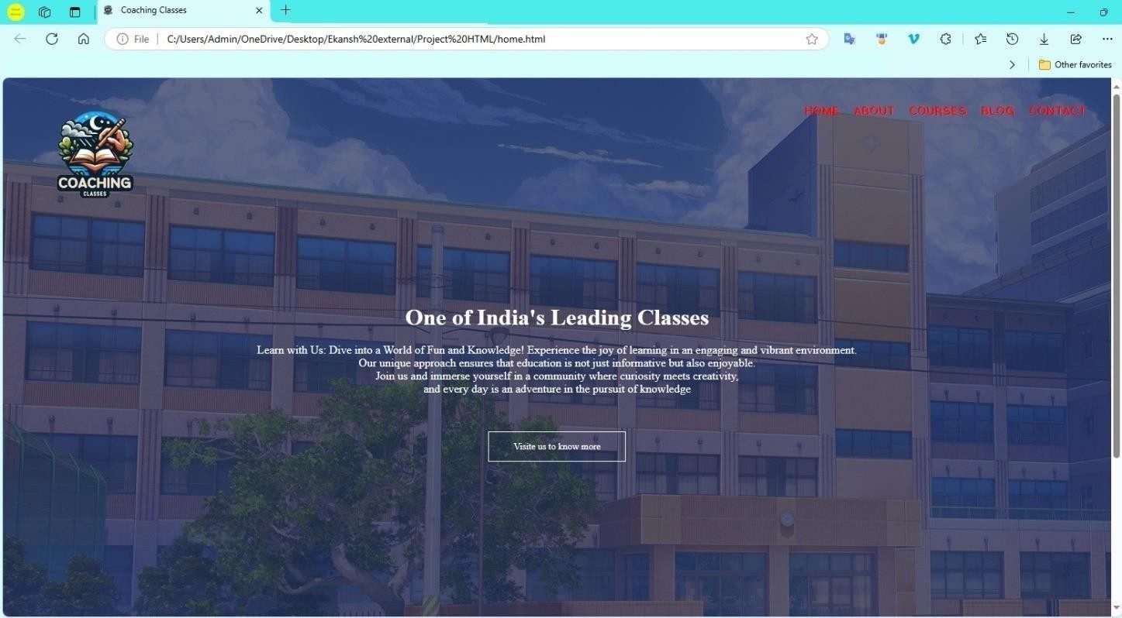

2. about.html:
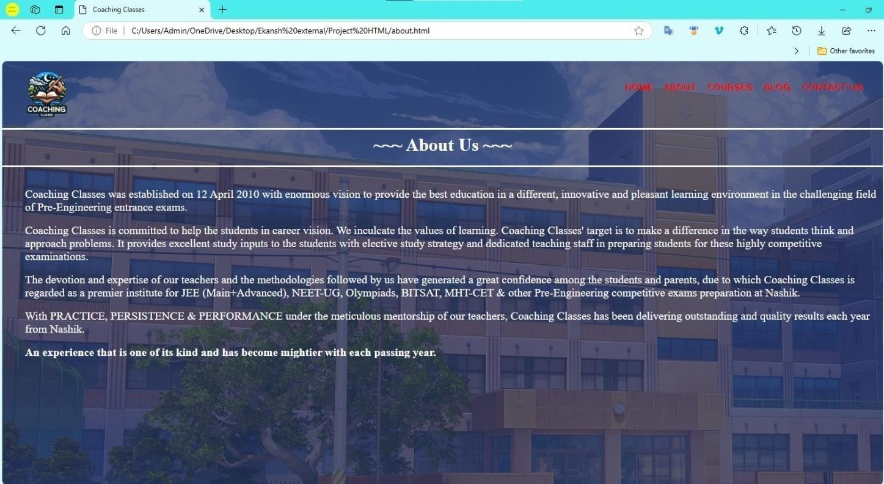

3. courses.html:
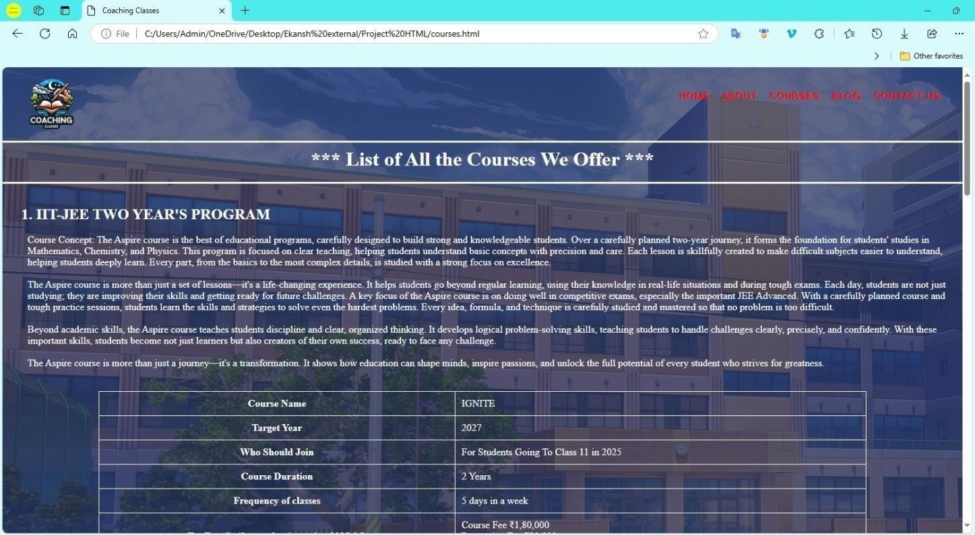

Courses 1

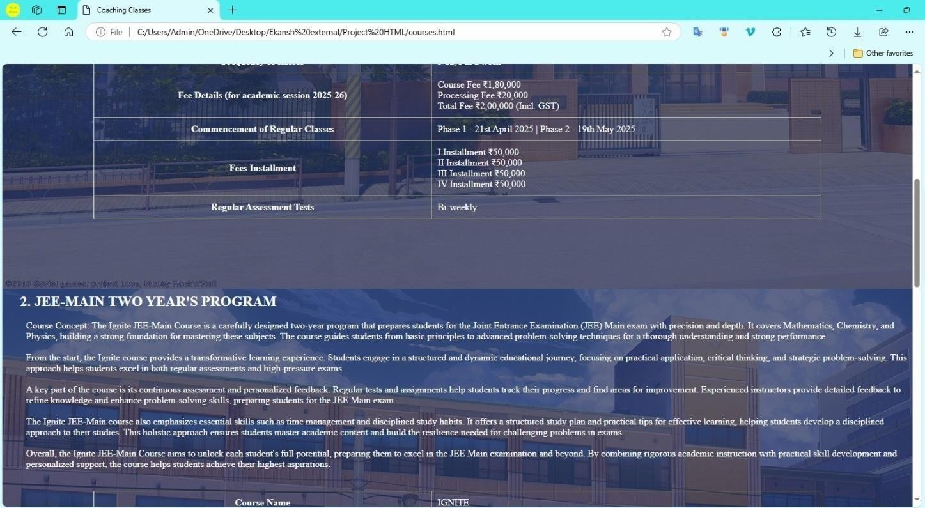
Courses 2

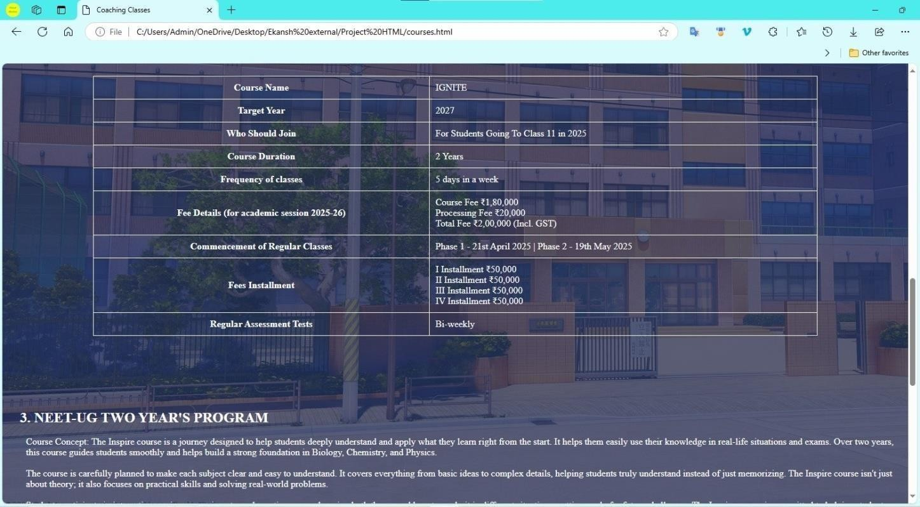

Courses 3

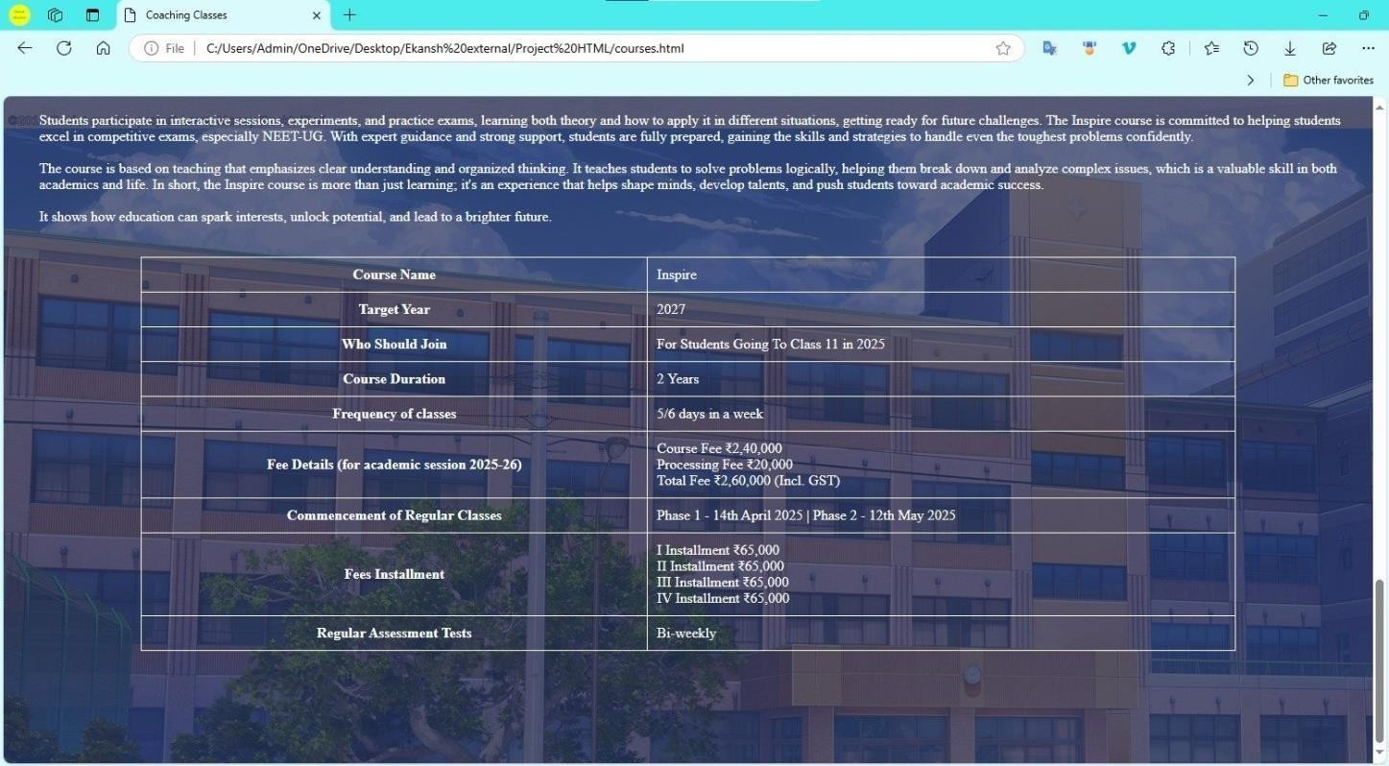
Courses 4

4. blog.html
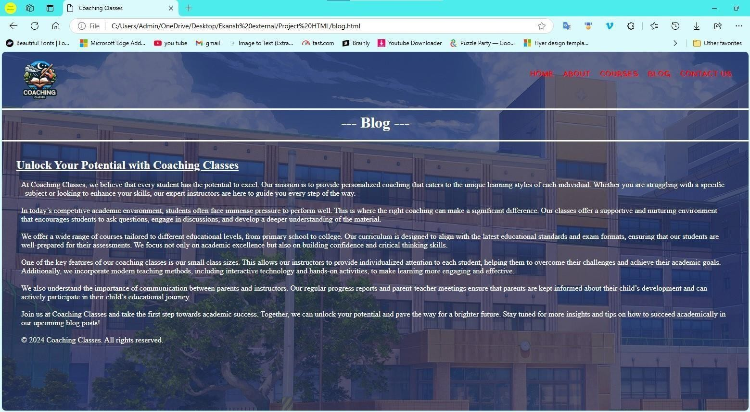

5. Contact.html
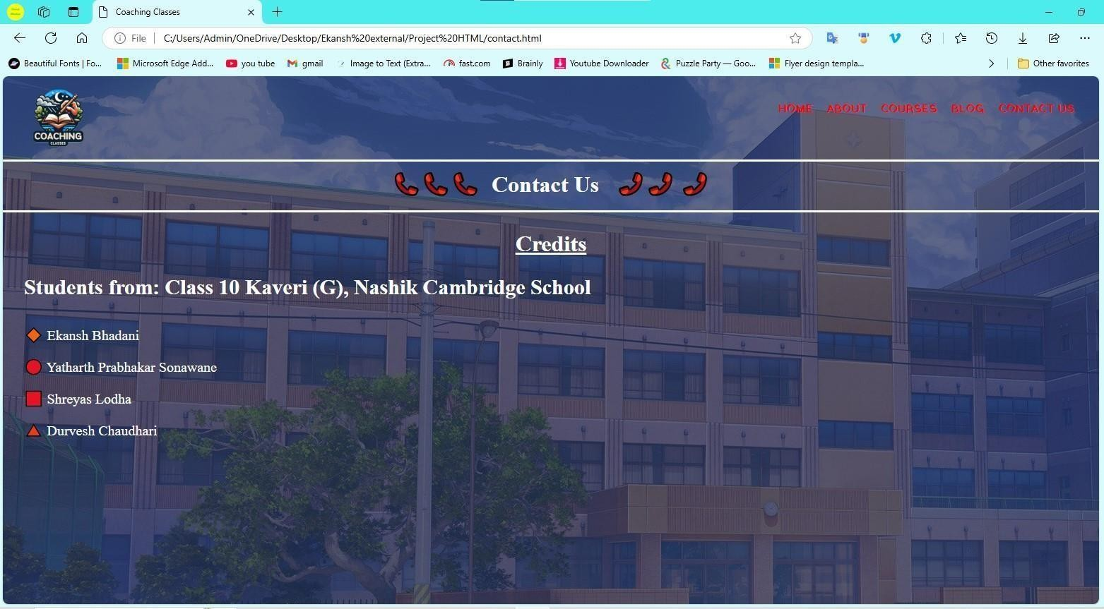

Conclusion
Through this HTML project we learnt different tags used. We learnt the tags for Hyperlink, Bold texts, Paragraphs, Teletype texts, Unordered list, Ordered list, Standard data cell, Thematic break, Subscript texts, Single line break, HTML Headings, Superscript text, Preformatted text, Relationship between Current document and External resource, Title of the document, Specification of Font face, Font size and Color of text, Document’s body, Strong importance texts and also Center align text. We also learnt about some of the Tags which have certain Attributes such as :-
- Unordered List [<ul>]:- a. Compact
b. Type

- Ordered List [<ol>]:- a. Type
b. Start

- Standard data cell [<td>]:- a. Colspan
  - Rowspan
  - Headers

- Horizontal Rule [<hr>]:- a. Align
  - Color
  - Noshade
  - Size
  - Width
- Image [<img>]:- a. src
  - alt
  - crossorigin
  - height
  - width

- HTML Document [<html>]:- a. Dir
b. Lang

- Document’s Body [<body>]:- a. Alink
  - Backround
  - Bgcolor
  - Link
  - Text
  - Vlink

Some Tags other than syllabus that are used are Footer for a document, Metadata about HTML document and Division. We got an opportunity to learn HTML Tags and their Attributes, which would be an addition to our knowledge and we could use these Tags to get more comfortable with computers.

References

  - https://youtube.com/playlist?list=PLjwm_8O3suyP5kGKmwS_DM0Hs1j7fshi5&si=KsP8hpKlXaUofyO7

  - Download this whole Project from Google Drive: (*download the folder named “Project HTML 2024-25 by Ekansh and group” on your pc and open file home.html to view the website)

https://drive.google.com/drive/folders/1CsnPajeNy9FOyPoqKrhKNT2Dcs2XzogC?usp=sharing

